**PARKING LOT MANAGEMENT SYSTEM**

Software Requirements Specification

**Group 5394_RR_1**

**Prepared by**

Aishwarya Rana

Jaya Naga Bhavana Kommuru

Mehak Agarwal

Michael Ndame

Sivaranjani Karuppannan Subbarayan

Table of Contents

1. Introduction 1

1.1. Purpose 1

1.2. Scope 1

1.3. References 1

1.4. Overview 1

2. Overall Description 1

2.1. Product Perspective 1

2.2. Product Functions 2

**2.2.1.** **Check-in** 2

**2.2.2.** **Parking a Vehicle** 2

**2.2.3.** **Locate parking slot** 2

**2.2.4.** **Check-out and Payment** 3

**2.2.5.** **Admin Functionality** 4

2.3. User Characteristics 6

2.4. Assumptions and Dependencies 6

3. Specific Requirements 6

3.1. Functional Requirements 6

**3.1.1.** **Check-in** 6

**3.1.2.** **Parking a Vehicle** 7

**3.1.3.** **Locate parking slot** 7

**3.1.4.** **Check-out and Payment** 7

**3.1.5.** **Admin Functionality** 8

3.2. Non-functional Requirements 8

**3.2.1.** **Performance** 8

**3.2.2.** **Availability** 8

**3.2.3.** **Reliability** 8

**3.2.4.** **Security** 9

# **Introduction**

## **Purpose**

The purpose of this document is to specify the requirements of Parking Lot Management System. The software requirement specification will describe the functionality, performance, external interfaces, attribute and any design constraint on the implementation. The intended audience of this document are the development team members of the project who will be implementing the project and the stakeholders who are investing in the design of the system.

## **Scope**

The scope of the project is to create and implement a parking lot management system. The system will allow a customer to use the parking lot to park his/her vehicle. The customer will be charged according to the pricing policy of the system. The system keeps track of frequent parker customers and allows them to use Frequent Parker points to make the payment. System will allow authorized admin users to login and update parking rates, view customer details and analyze parking data.

## **References**

[1] IEEE Software Engineering Standards Committee, "IEEE STD 830-1998, IEEE Recommended Practice for software Requirement Specifications", October 20, 1998

## **Overview**

The following sections of the SRS is organized as follows:

**Section 2** will give the overall description of each functionality found in the system.

**Section 3** will give more technical details of the system functionalities.

# **Overall Description**

## **Product Perspective**

The parking lot management system is not a self-contained application. It allows the user to interact with the database to store information of the customer and help to retrieve data related to customer.

## **Product Functions**

### **Check-in**

**Description**: **This function allows a customer to check-in to the parking lot.** The customer arrives at check-in kiosk, swipes his/her credit card. The credit card will be pre-authorized. User will enter vehicle number and vehicle type. The vehicle types allowed are motor cycle, car and buses.

**Rationale**: This function grants user access to parking lot.

### **Parking a Vehicle**

**Description: This function allows the user to select and reserve a slot for parking.** After check-in, parking layout highlighting the available parking slots based on the vehicle type will be displayed to the customer. If the vehicle type is motor cycle, all the available slots are highlighted and displayed to the customer. If the vehicle type is car, all available single compact spot or a single large spot is displayed. If the vehicle type is Bus, only the available large spots are displayed to the customer. Few accessible parking lots are also available for each vehicle type at the first level which will be highlighted uniquely and displayed to the user. Customer selects a slot and parks his/her vehicle on that slot.

**Rationale:** It allows user to select the parking slot that suits him/her.

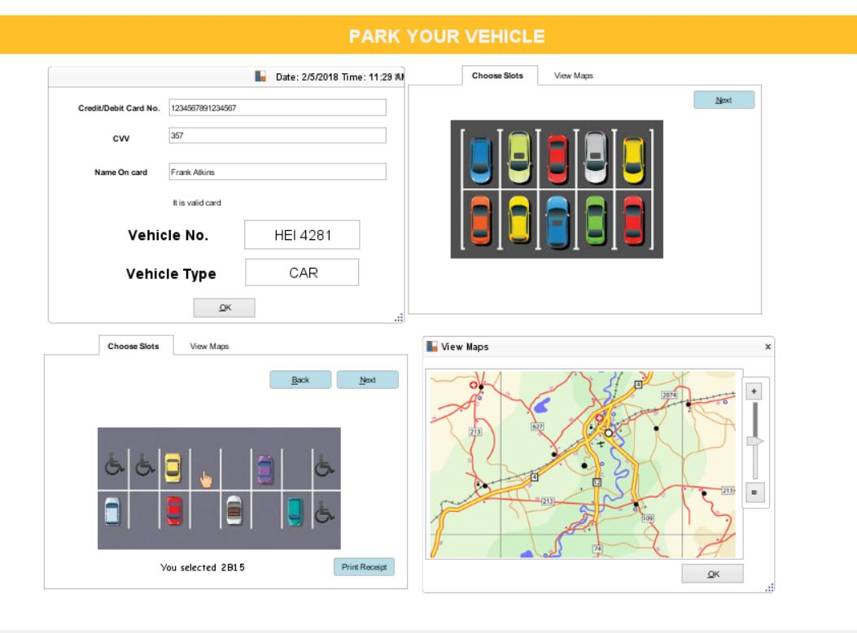

Figure 1 Check In and Parking Vehicle

### **Locate parking slot**

**Description: This function allows a customer to locate a particular parking slot.** Customer can use map functionality to find the route to the parking slot selected in step 2.2.2 or locate parking slot by providing Vehicle number.

**Rationale:**This function enables the user to locate a parking slot.

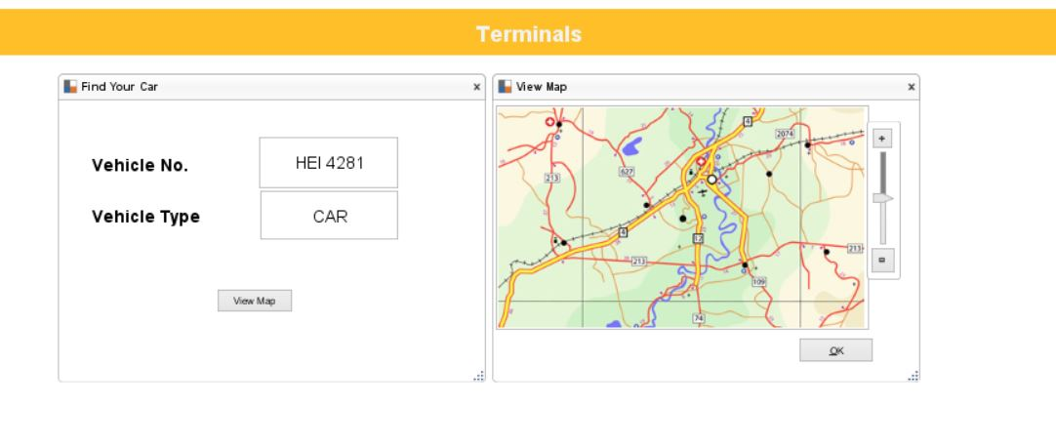

Figure 2Parking Location

### **Check-out and Payment**

**Description: This function allows the customer to Check-out.** The customer arrives at check-out kiosk and swipes same credit card that was used during check-in. If the customer is Frequent Parker, then he/she can enter his/her rewards number which is the registered phone number. The customer will also be given an option to redeem Frequent Parker points and rest of the amount will be settled from pre-authorized transaction and receipt is displayed. If the customer is not a Frequent Parker, then a receipt is displayed and charges are deducted by settling the pre-authorized transaction.

**Rationale:**This function allows customer to exit the parking lot*.*

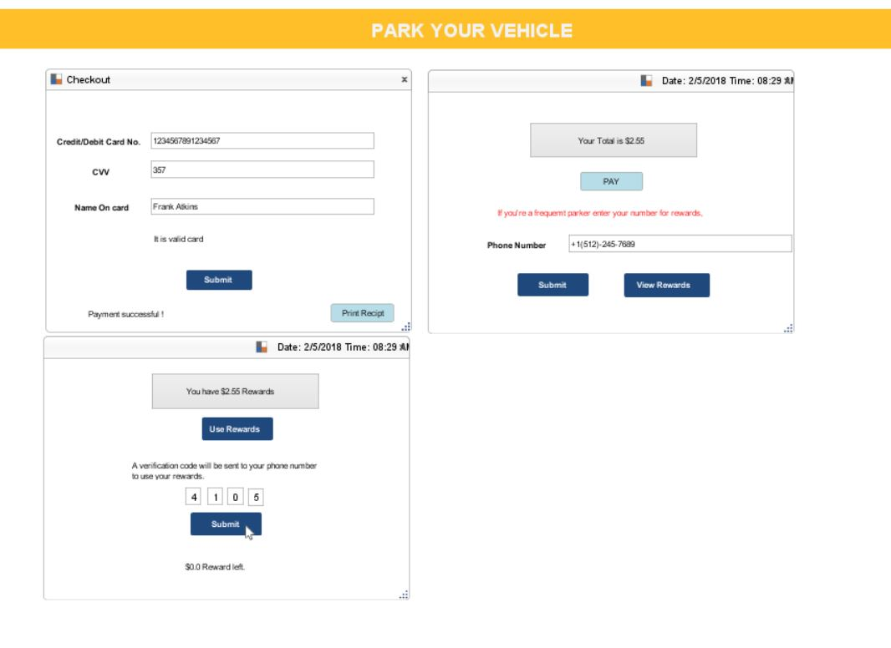

Figure 3 Checkout

### **Admin Functionality**

**Description: The admin functionality allows authorized admin to login to system and register new frequent parker customers, update account information of registered customers, view parking statistics and update parking rates.** The admin can login and register new frequent parker customers by entering their name, phone number, email address. The customer’s phone number can be used to add rewards points. The admin can also update any information related to a customer’s account. The admin can also view parking statistics like busy hours, usage of parking area, retrieve parking history, vehicle lookup.

**Rationale:** This offers convenience to the admin to update rates and lookup any data easily.

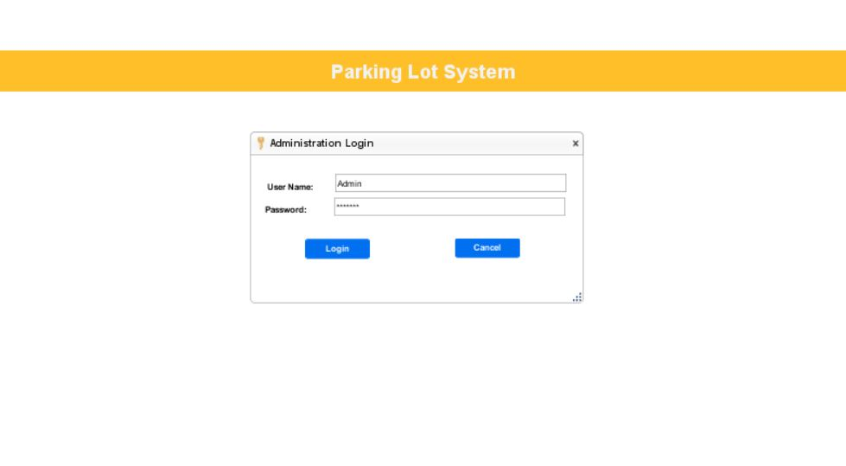

Figure 4 Admin Login

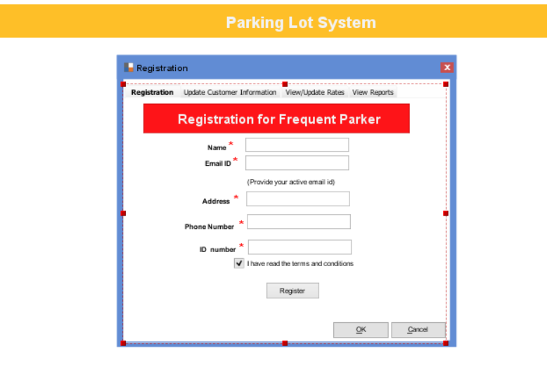

Figure 5 Registration for frequent parker

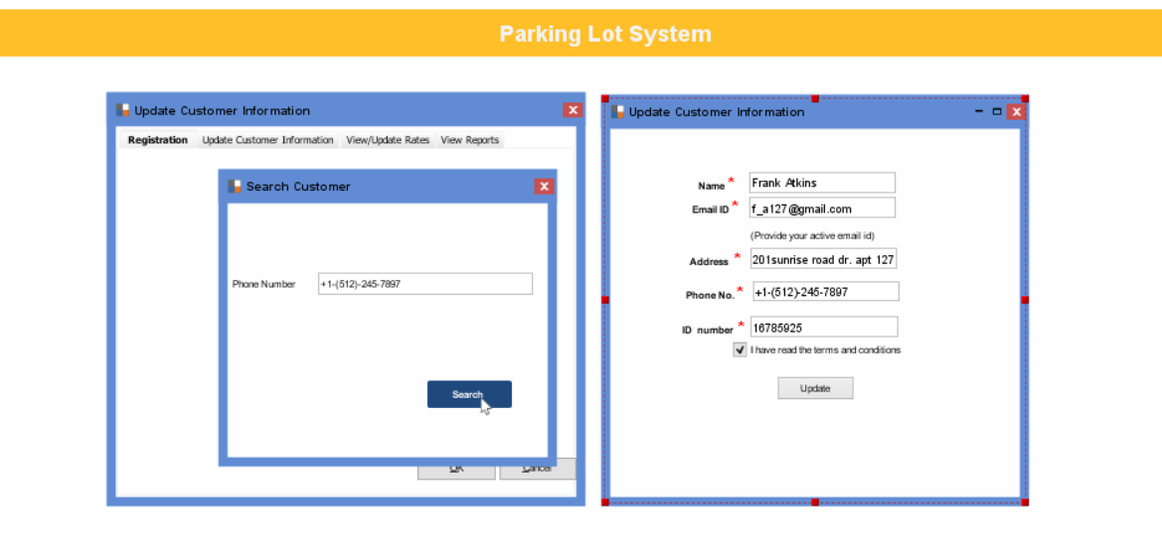

Figure 6 Update customer Information

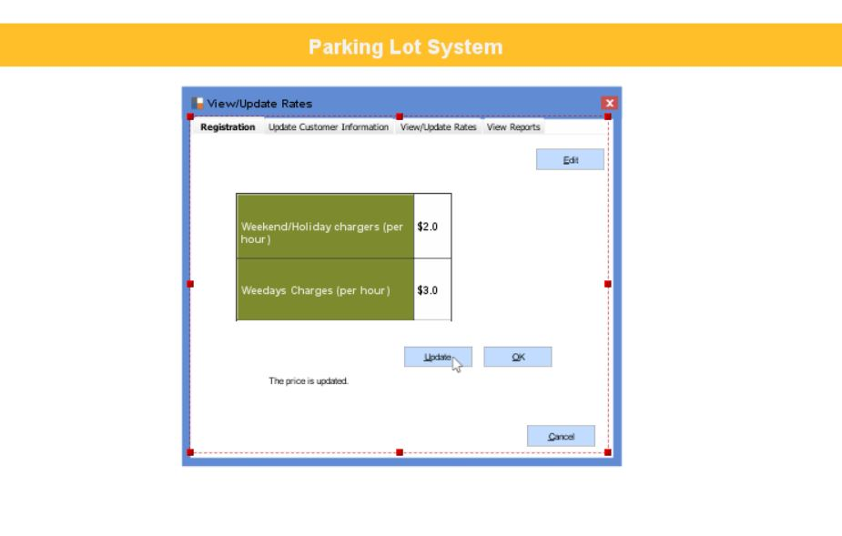

Figure 7 View/Update Rates

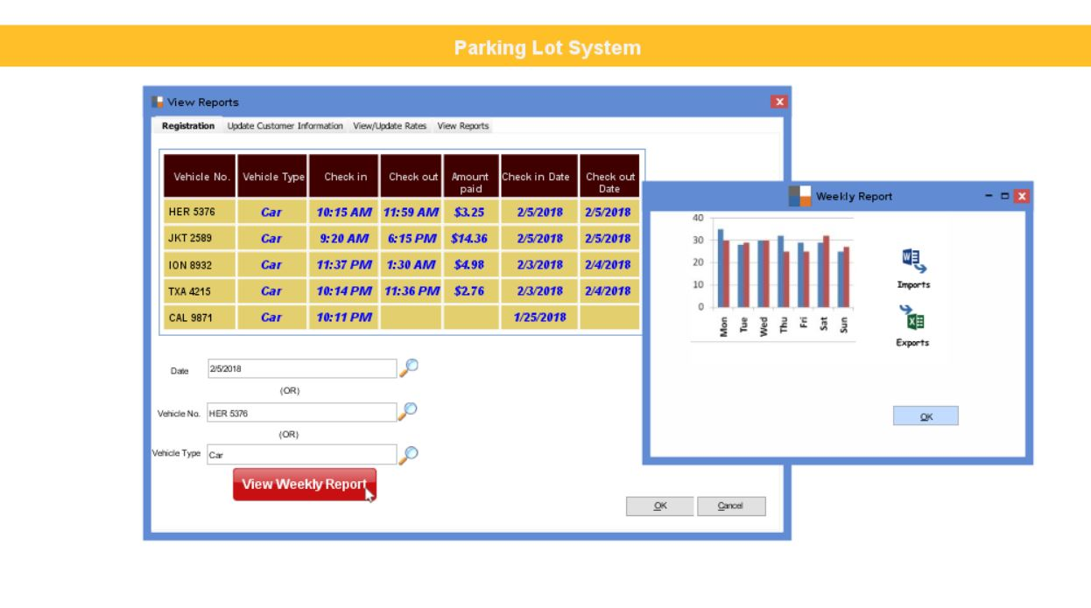

Figure 8 View report

## **User Characteristics**

The user is expected to have knowledge about how to use a computer application. And the parking customer should have a valid credit/debit card.

## **Assumptions and Dependencies**

This software runs on multiple window machines connected to a network and having internet access. During check-in, customer will provide 16-digit credit card number, vehicle number and vehicle type. In real-life scenario, 16-digit credit card number will be provided to the system by credit card swiping machine. Vehicle type and number will be provided to the system by a sensor at the check-in site.

In real scenario, after check-in, the customer can park the vehicle at any vacant slot. Once vehicle is parked, the parking sensor will update the parking location of the vehicle. For development, the vehicle parking location will be updated manually.

# **Specific Requirements**

## **Functional Requirements**

### **Check-in**

|  |  |
| --- | --- |
| **Title** | **Description** |
| **Description** | See Section 2.2.1 for Description. |
| **Inputs** | Vehicle number, Vehicle type and 16-digit credit card number. |
| **Source** | All inputs are provided by the user. |
| **Output** | Available parking slots will be displayed. |
| **Destination** | The output will be displayed on the screen. |
| **Pre**-**condition** | Customer arrives at parking check-in lot and swipes a valid card. |
| **Post**-**condition** | Available parking slots are displayed. |
| **Side-effects** | None. |

### 

### **Parking a Vehicle**

|  |  |
| --- | --- |
| **Title** | **Description** |
| **Description** | See Section 2.2.2 for Description |
| **Inputs** | Customer selects a parking slot. |
| **Source** | Input is provided by the user. |
| **Output** | The parking slot is booked for that vehicle. |
| **Destination** | None. |
| **Pre**-**condition** | The customer has checked-in. |
| **Post**-**condition** | Parking slot selected by customer is now booked. |
| **Side**-**effects** | None. |

### **Locate parking slot**

|  |  |
| --- | --- |
| **Title** | **Description** |
| **Description** | See Section 2.2.3 for Description |
| **Inputs** | Vehicle number. |
| **Source** | All inputs are provided by the user. |
| **Output** | Map showing the route from customer's current location to the vehicle parking slot will be displayed. |
| **Destination** | The map showing the route will be displayed on the screen. |
| **Pre-condition** | The customer has successfully reserved a parking slot. |
| **Post**-**condition** | None. |
| **Side**-**effects** | None. |

### **Check-out and Payment**

|  |  |
| --- | --- |
| **Title** | **Description** |
| **Description** | See Section 2.2.4 for Description |
| **Inputs** | 16-digit credit/debit card number. If the customer is Frequent Parker, then customer is given an option to redeem points. |
| **Source** | All inputs are provided by the customer. |
| **Outputs** | Receipt is generated for customer. |
| **Destination** | Printed receipt is generated. |
| **Pre**-**condition** | Customer has parked the vehicle. |
| **Post-condition** | Customer is charged for parking and pre-authorized transaction is settled. |
| **Side**-**effects** | None. |

### 

### **Admin Functionality**

|  |  |
| --- | --- |
| **Title** | **Description** |
| **Description** | See Section 2.2.5 for Description |
| **Inputs** | Customer information to register/update a frequent parker, updated parking rates to change prices |
| **Source** | All inputs are provided by the employee(admin) |
| **Outputs** | Admin can register frequent parker customer, update a frequent parker’s information, update parking rates and analyze parking statistics |
| **Destination** | The frequent parker is registered/updated and the parking rates are updated |
| **Pre**-**condition** | Admin has the credentials to access admin dashboard. |
| **Post-condition** | Customer is able to use frequent parker program after registration. If the price is updated, billing is done based on the update |
| **Side**-**effects** | None. |

## **Non-functional Requirements**

### **Performance**

1. After a vehicle has passed the entrance/exit gate, the gate has to close within 5 seconds.
2. The system should check-in vehicle only if there is an available slot. In other words, for each vehicle that enters the parking lot, there is a parking space available.
3. The system should always display the correct output to the customer.

### **Availability**

The system should be available all the 24 hours of the day and all 7 days of the week.

### **Reliability**

The system should function correctly even if a customer inputs invalid information.

### **Security**

Only authorized employees should be given admin access to modify parking rates as well as view and edit customer information.